URS Document

Group B
Members: Ishant Upadhyay, Raditya Surya Pratama, Francky Ngabo, Ji Nan, Hamid Reza Heydari, Hasan Lapa

Table of Contents
1. Introduction 5
2. Function Requirement 5
Use-Cases: 5
1. Open and close the program. 5
2.Save File 6
3.Load File 7
4.Create a new traffic stimulation file. 7
5.Adding crossroad map 8
6.Removing crossroad map 8
7.Increase or decrease Number of cars or pedestrians 9
8. Increase or decrease Number of cars 9
9. Adjust Traffic light duration 10
10.Start/Pause Simulation 10
11.Stop Simulation 11
System Components 11
Flow Diagram for Use Cases: 12
Open application 12
Close applicaton 12
Save File 13
Load File 13
Create New 14
Add map to grid 14
Remove map 15
Car Setting 15
PedesteriaSettings 17
Start/Pause the application 19
Stop Application 20
Light Time Duration 21
3.User Interface 22
4.Non-Functional Requirements 22
Usability 22
Testability 22
Performance (Response Time) 22
Robustness 22
System Requirement 23
5.MoSCoW 23
6.Limitations: 23
Transportation stream 23
Pedestrian stream 24
Speed 24
Crossing 24
Operation 24
7.Traffic Light 24

Introduction

The goal of the current document is to find out the needs and requirements of traffic light project.
In the following parts, we will be discussing the necessary requirements of the project. It is very important to initialize the user’s requirements in advance so we can avoid any misunderstanding and help improve the quality of the project.
We can categorize the requirements in two sections:
1. Functional Requirement
2. Non-functional Requirement

Function Requirement

Some features of the product which represent the functionality of the software.
The following is the functional requirement:
- Open and close the program.
- Save the file.
- Load the file
- Create new file.
- Adding crossroad map
- Removing Crossroad map
- Increase or decrease Number of cars
- Increase or decrease Pedestrians
- Adjust Traffic light duration
- Pause –Start Simulation
- Stop Simulation

Use-Cases:

1. Open and close the program.

Open Program
Goal: Open the application.
Actor: User.
Pre-Condition: User has installed the application.
MSS:
- User double-click on the icon of the application.
- Program starts and main window appears.

Close Program
Goal: Close Application.
Actor: User.
Pre-Condition: *The application is running.

MSS:
- User clicks the X sign on the right-top button.
- System close the application.

Exception:
1a- System asks if you want to save go to use case Save file.

2. Save File
Goal: To Save the File
Actor: User
Pre-Condition: The application window is open.
MSS:
- User clicks save simulation button.
- System displays a confirmation window.
- User clicks save and choose the location of the file.
- System saves the file.

Exception:
3a-user clicks no.
b-system don’t save the file.

3.Load File

Goal: To load saved File
Actor: User.
Pre-Condition: The main form is open.
MSS:
- User choose the load option
- System displays a browsing window.
- User chooses the desired file.
- System loads the file.

Exception:
4a-System displays a message that the type of file is not a valid type and asks user to select valid one.

4. Create a new traffic stimulation file.

Goal: Creation of a new simulation project.
Actor: User.
Pre-Condition: *The application is running.
*There is no other existing
MSS:
- User choose the create new option.
- System creates a new traffic simulation.

5.Adding crossroad map
Goal: Add Map to application
Pre-Condition: User is on the main form.
Actor: User
MSS:
- User selects the map and chooses a place inside the grid to put that map.
- The system show whether the selected grid is empty or not.
- The system add new map on the selected grid.
Extension:
2a. There is already existing map on that location.
System asks actor if it should override existing map.
- User selects Yes and the system overrides map.
-User selects No and return to the main screen.
b. User searches for a new location.

6.Removing crossroad map
Goal: Removing Map from the application
Pre-Condition: User is on the main form.
Actor: User
MSS:
- User select the map which he/she want to remove.
- User right click inside that selected map and choose delete.
- The system show pop-up window whether he/she want to delete it or not.
- User select yes.
- The system delete the map in that selected grid.
Extension:
4a. User select No.
System will not delete the map.

7. Increase or decrease Number of cars or pedestrians
Goal: To increase Number of Pedestrians
Actor: User
Pre-: The simulation is running,
MSS:
- Actor double clicks the desire area on the map.
- System pause the simulation
- System zoom the desired area.
- Actor increase or decrease the number of Pedestrians.
- Actor choose the confirms option.
- System save the changes made.
EXT:
3)1. Actor chooses to close the zoomed area. Use case ends.
5)1.Actor chooses the cancel option. User goes back to case 4.

8. Increase or decrease Number of cars
Goal: To increase the number of cars.
Actor: User
Pre-: The simulation is running.
Mss:
- Actor double clicks the desire area on the map.
- System pause the simulation.
- System zoom the selected area
- Actor chose the incoming or outgoing area
- Actor increase or decrease the number of cars.
- Actor choose the confirm option.
- System save the changes made.
EXT:
3)1. Actor chooses to close the zoomed area. Use case ends.
5)1.Actor chooses the cancel option. User goes back to case 4.

9. Adjust Traffic light duration
Goal: Light time setting.
Pre-Condition: User is in the main form.
Actor: User
MSS:
- User select the map and double click it.
- The system show the current map in enlarge form.
- User choose the time duration from options and select apply.
- The system adjust to the new setting.
- The system show the map with new setting.
Extension:
3a.User did not select apply.
-The time duration will be the set to the default one.

10.Start/Pause Simulation
Goal: Start and Pause application
Pre-Condition: User is in the main form.
Actor: User
MSS:
- User click Start/Pause button.
- The system check the status.
- The system show the current status in the main form.
Extension:
2a. If the stimulation system is running.
-The system will paused the application.
b.If the stimulation system is paused or not started.
-The system will start the system again.

11.Stop Simulation
Goal: Stop Simulation
Pre-Condition: User is in the main form.
Actor: User
MSS:
- User click Stop button.
- The system check the status.
- The system show the current status on the main form.
Extension:
2a. If the stimulation system is not running.
-The system will show main form.

System Components
The main components of our simulation system is as follow:
- Traffic-Control-form: The project will load to the main form.
- Crossroads.
- Traffic- lights.

Flow Diagram for Use Cases:

Open application

Close applicaton

Save File

Load File

Create New

Add map to grid

Remove map

Car Setting

Pedesterian Settings

Start/Pause the application

Stop Application

Light Time Duration

3.User Interface
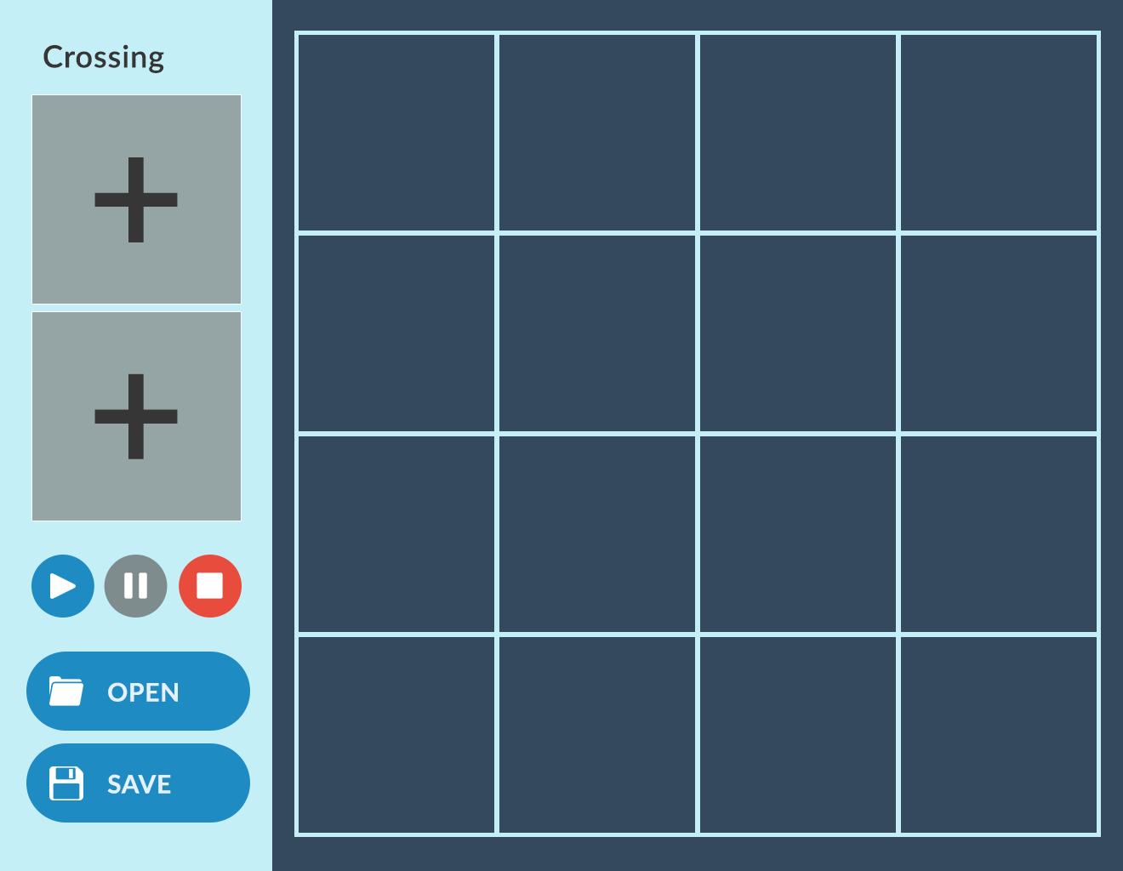

4.Non-Functional Requirements

Usability
The application should be easy to use and understand by the user.

Testability
The application should be tested by some people, to ensure the application are working properly without bugs, problem and giving the specified result that user expected.

Performance (Response Time)
The application should start quickly without taking a long period of time to load.

Robustness
The application should be able to cope with errors during execution. It should give a meaningful error message if it’s encounter any problem and should not crash.

System Requirement
Operating system: Windows Vista / 7 / 8 / 8.1
CPU: Pentium 4 1.5 GHz or higher
.NET Framework: .NET 3.5 or higher
Hard Drive: 50 MB of free hard disk space
Display: 800x600 or higher resolution monitor

5.MoSCoW

Activity (Use-case) | M | S | C | W
Adjust distribution of cars between lanes | X
Adjust nrumber of pedestrians per minute | X
Adjust “Green Light” time | X
Add crossroiad on the grid | X
Remove croassroad | X
Save crossroad map | X
Laod crossroad map | X
New crossroad map | X
Start/Pause simulation button | X
Adjust car flow into croassroad from outside | X
Stop system button | X
Modify crossroad |  | X
Change direction of cars |  |  | X
Remove a car |  |  | X
Rotate crossroad |  |  | X
Add a car in the middle of crossroad |  |  |  | X
Remove pedestrians |  |  |  | X

6.Limitations:
In order to maintain the performance of the Traffic Control Simulation, we set a certain amount of limitations. Here is the list of different limitations.

Transportation stream
- Type of vehicles
- Maximum number of vehicles shown at the traffic lights.
- Maximum number of vehicles coming outside the crossing.

Pedestrian stream
- Maximum number of pedestrians shown at the traffic lights.
- Minimum and maximum number of pedestrians coming to the traffic lights.

Speed
- Vehicle speed.
- Pedestrian speed.

Crossing
- Minimum and maximum number of crossings.
- Adding & Removing Crossings.
- Type of crossings.

Operation
- Operations of the timer.
- Operations of the start, pause and stop.
- Operations of the performance.

7.Traffic Light
To specify the time duration of traffic light, we need to consider the speed of the cars. We suppose that the cars are inside the city so they do not have speed more than 80 km/h.

Depending on the speed of car, the required duration to change from green into yellow light will be as following:
a) 50km/h: the duration of yellow light will be 3 seconds. We assume a car with speed 50km/h needs almost 2 seconds to stop.
b) 80km/h: the duration of yellow light will be 5 seconds. We assume a car with speed 80km/h needs 3 seconds to stop.

